Types of Adjectives
# Source: AI Source: Provided by: [Data Path: Persons Table -> ID Column: 1, Name_En Column: Motasem Essam] -> From: [Chatgpt (GPT-4-turbo)] on [7/27/2025]
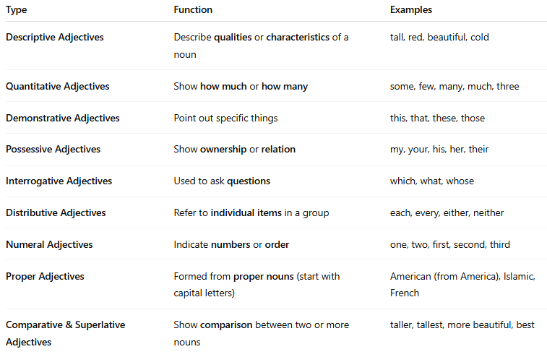

Type | Function | Examples
Descriptive Adjectives | Describe qualities or characteristics of a noun | tall, red, beautiful, cold
Quantitative Adjectives | Show how much or how many | some, few, many, much, three
Demonstrative Adjectives | Point out specific things | this, that, these, those
Possessive Adjectives | Show ownership or relation | my, your, his, her, their
Interrogative Adjectives | Used to ask questions | which, what, whose
Distributive Adjectives | Refer to individual items in a group | each, every, either, neither
Numeral Adjectives | Indicate numbers or order | one, two, first, second, third
Proper Adjectives | Formed from proper nouns (start with capital letters) | American (from America), Islamic, French
Comparative & Superlative Adjectives | Show comparison between two or more nouns | taller, tallest, more beautiful, best

